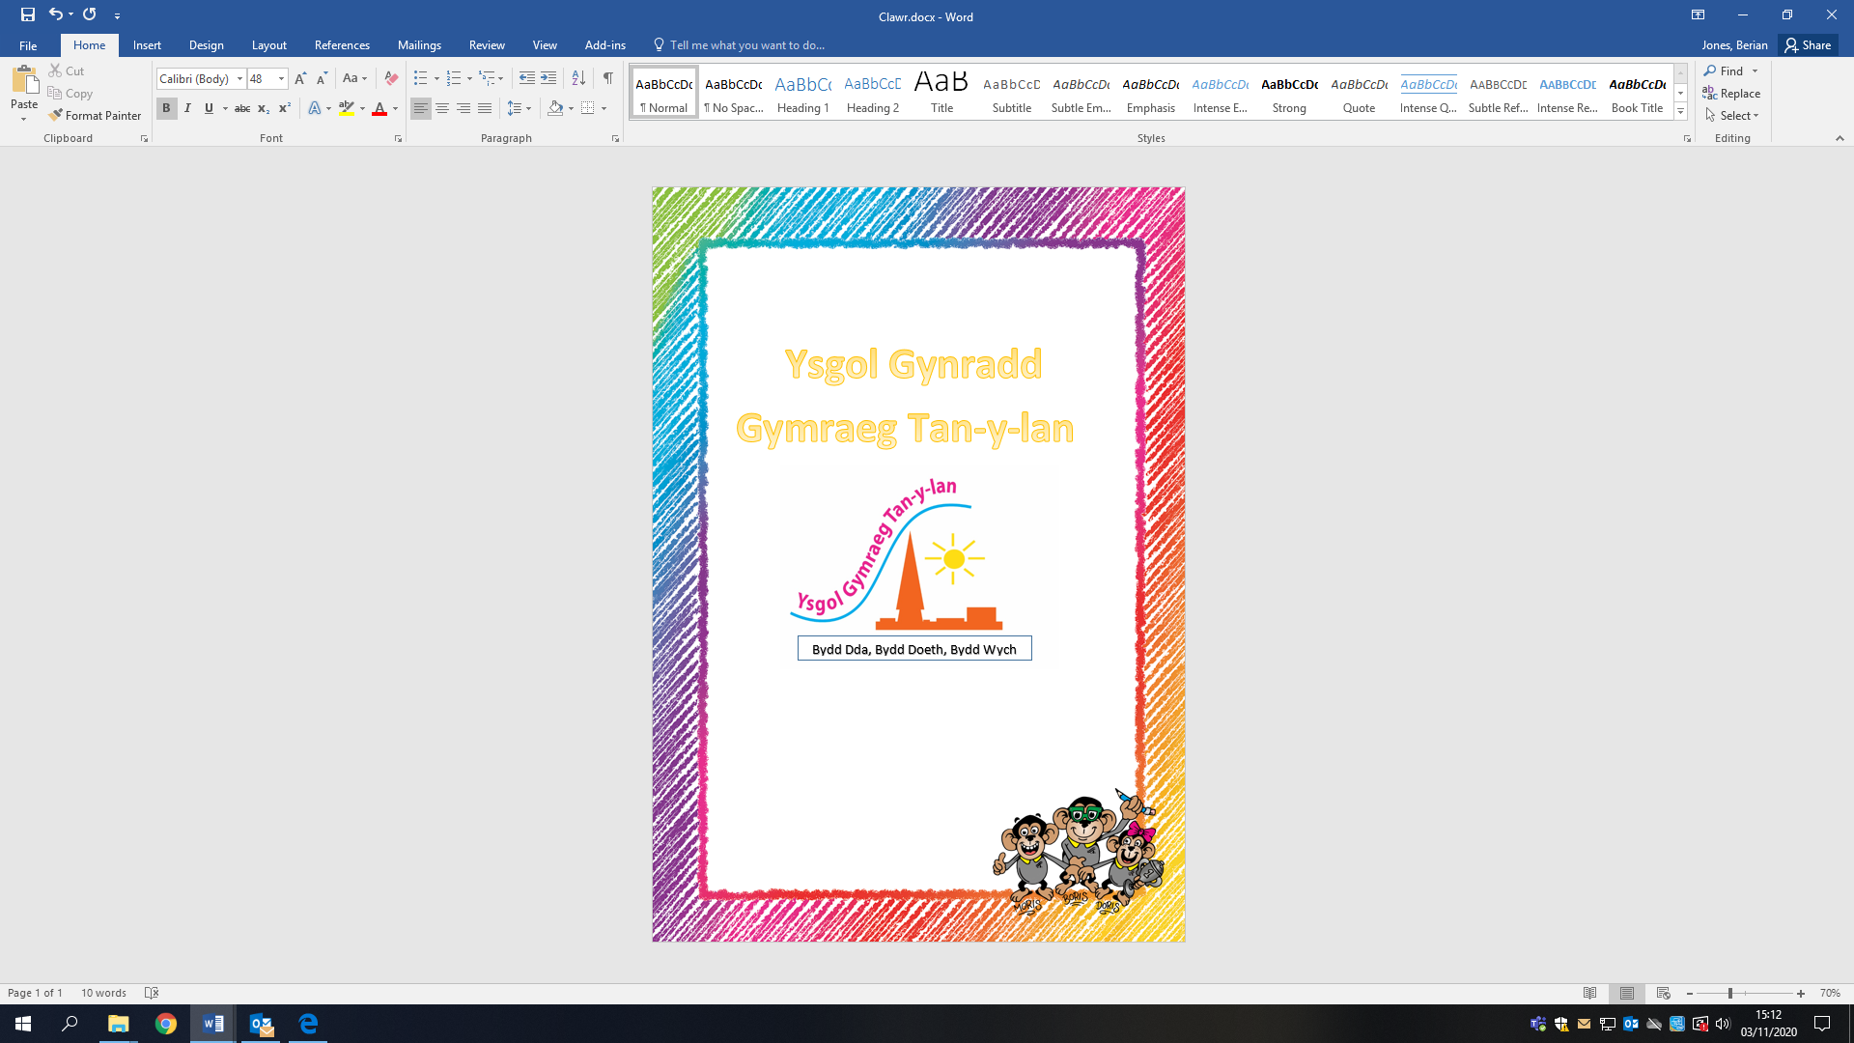

Policy for
Positive Behaviour

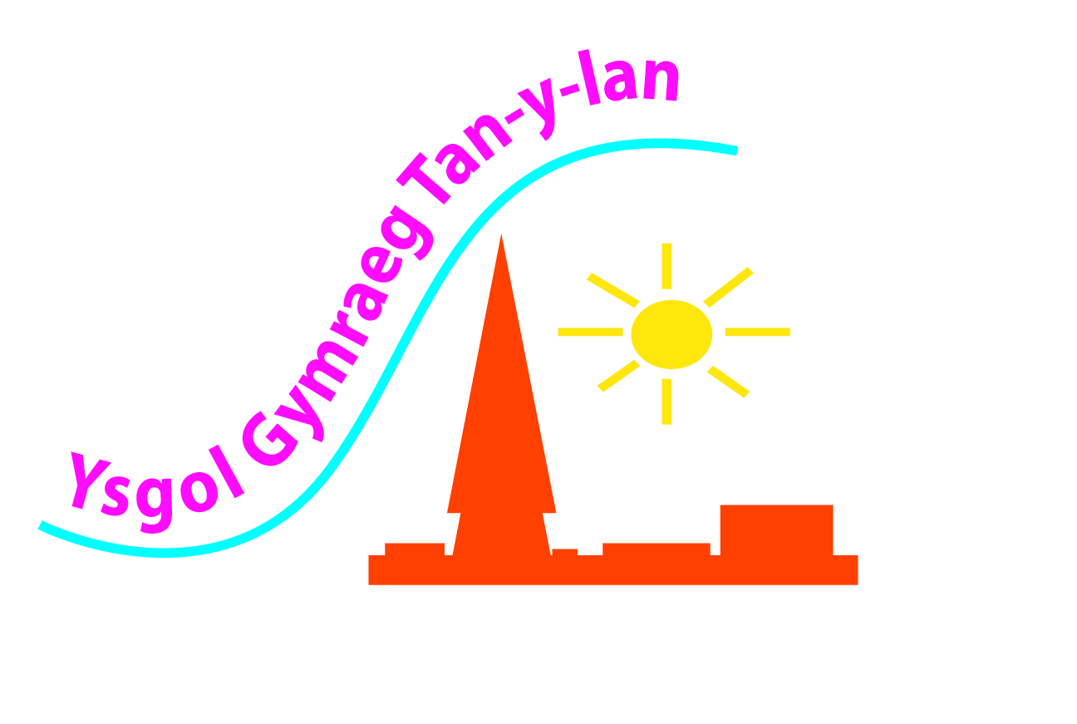

Ysgol Tan-y-lan
Policy for
Positive Behaviour

The United Nations Convention on the Rights of the Child (CRC) is central to the plans, policies, practice and ethos of our school. As a rights-respecting school, we teach about children’s rights and also model rights and respect in every relationship – Linked to Articles 3, 32 (CRC)

Aims and Expectations

One of the main aims of our school is that every member of the school community feels safe, valued and respected, and that every child is treated fairly and well. We are a caring community, whose values are built on mutual trust and respect for everyone. Therefore, the school behaviour policy has been designed to support the way in which every member of the school can live and work together in a supportive way. Its aim is to promote an environment where everyone feels happy, secure and safe. It is the responsibility of all staff to promote good behaviour.

The school has a number of rules. This means promoting good relationships, so that people can work together with the same goal, namely helping everyone to learn. This policy supports the school community in seeking to enable everyone to work together in an effective and considerate way.

The school expects every member of the school community to behave considerately towards others.

We treat every child fairly and follow this behaviour policy consistently.

The school rewards good behaviour, as it believes that this will develop an ethos of kindness and cooperation. This policy has been designed to promote good behaviour, rather than simply prevent antisocial behaviour.

Teachers have the right to teach and pupils have the right to learn in a classroom free from disruptive behaviour – a classroom that reflects the teacher’s own behavioural expectations and creates an atmosphere in which pupils’ self-esteem can flourish.

Code 4: Must Do – Welsh-medium Tan-y-lan School

All school stakeholders have worked together to create a personalised plan for use across the school to celebrate positive/excellent behaviour and to avoid problems and unacceptable behaviour. As a result of all this work, members of the School Council, the wellbeing officer and the family engagement officer created visual resources for use in every class and across the school.

Four Code statements were established for the school

- Celebrate our Welsh identity
- Accept responsibility
- Show respect
- be happy and ready

These 4 statements (4 must dos) are displayed around the school/in every classroom to remind all pupils of what is expected of them in school.
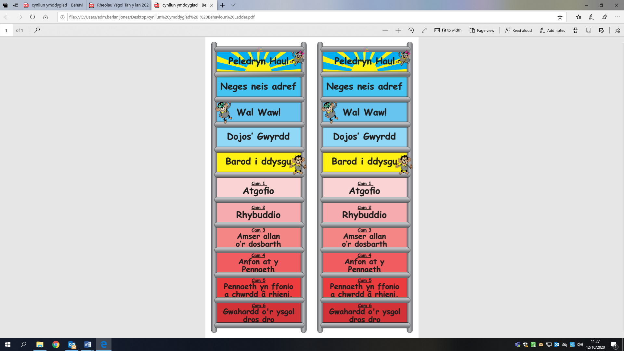

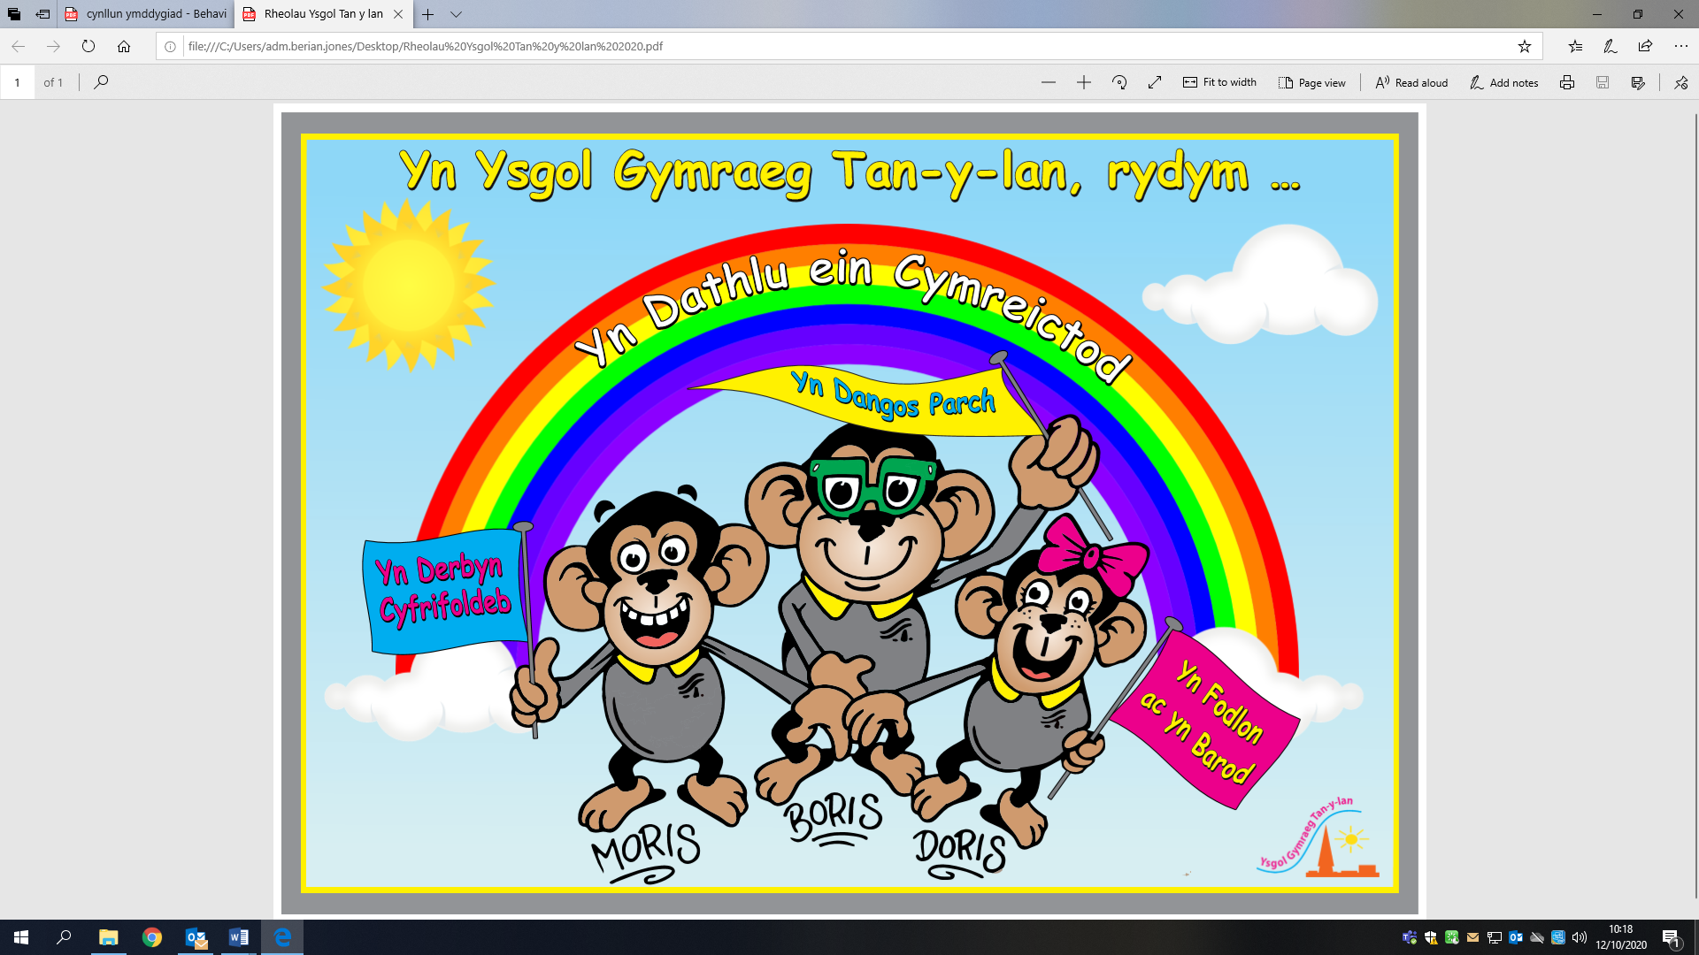

To go alongside the 4 must-do statements, the School Council
has created behaviour steps for use in our
classrooms. The purpose of these Behaviour steps is to provide a
visible resource showing the clear stages on the daily
behaviour journey.
Every child starts each day at the ‘ready to learn’ stage.
The skill of self-control enables each
individual to make decisions about how they are going to behave on a daily basis. The stages were set by the pupils together with the teachers. By using the child’s voice as part of the planning, this has enabled ownership of these systems and resources. Every pupil has a peg which moves up or down the school according to need. It is expected that the children take part in the discussion and understand why they are moving on the scale.

General School Rules
1. Bullying and racism are always unacceptable behaviour. Fortunately, most pupils in our school show a caring, responsible attitude.

2. Children are expected to be polite and helpful at all times. Dangerous and irresponsible behaviour, swearing and bad language are not acceptable.

3. Children are expected to walk in the school and to give way or hold doors open for younger children and adults.

4. To keep the school as “green” as possible, rubbish must be put in the containers provided in the school. We recycle paper, milk cartons, printer cartridges and batteries. We switch off electricity when it is not needed. We compost, close doors and turn off taps after use.

5. Children are not allowed to bring toys or games (including balls) to school, except with special permission, e.g. as part of a class project. If you disobey, and your property goes missing or is broken, the school will not be responsible.

6. Chewing gum and lollipops are not allowed in school.

7. Children should not be in the school buildings before school starts, after school finishes or during playtime, except with special permission.

8. Children should not come to school before 8.40am unless they are attending Breakfast Club.

9. Children are expected to change clothes for P.E., Swimming and Games.
Indoor P.E.: Shorts and a T-shirt for apparatus work.
P.E., Outdoor Games: A change of clothes is required, otherwise children will not be allowed to take part in the lesson.
N.B. Jewellery must not be worn during P.E. and Games lessons.

10. If a child is absent, or is expected to be absent, an explanation from the parents is required, in writing or verbally.

Rewards and Consequences
We praise and reward children for good behaviour in a variety of ways:
- teachers congratulate children
- every week, we hold a ‘Reward Assembly’ where children in each class are rewarded for their efforts
- class teachers give individual stickers and stamps to recognise effort, good behaviour etc.

The school uses a number of consequences to enforce the school rules, and to ensure a safe and positive learning environment. We use Restorative Practice approaches and strategies to discuss the consequences of incidents. We use each consequence appropriately according to each individual situation.
We expect children to listen carefully to instructions in lessons. If they do not, we ask them to move closer to the teacher, or to sit on their own.
We expect children to do their best in every activity. If they do not, we may ask them to redo a task.
If a child is disruptive in class, the teacher reprimands them. If a child repeatedly misbehaves, we isolate them from the rest of the class until they calm down and are in a position to work sensibly again with others.
The safety of the children is the most important thing in every situation. If a child’s behaviour puts the safety of other people at risk, the class teacher stops the activity and prevents the child from taking part for the remainder of that session.
If a child threatens, hurts or bullies another pupil, the class teacher discusses the incident with the child who has been bullied and the child who has been disciplined. If a child repeatedly behaves in a way that disturbs or upsets others, the school will contact the child’s parents and arrange an appointment to discuss the situation, seeking to improve the child’s behaviour.

The class teacher discusses the school rules and school aims with each class. In addition to the school rules, every teacher uses a variety of strategies and tactics to encourage positive behaviour and attitudes in their own classroom. In this way, every child in the school knows the standard of behaviour we expect in our school. If there are incidents of inappropriate behaviour, the class teacher discusses these with the whole class at the earliest convenient opportunity.

The school does not tolerate bullying of any kind. If we discover that an act of bullying or intimidation has occurred, we act immediately to prevent any further such behaviour. Although it is very difficult to eliminate bullying, we do everything in our power to ensure that every child comes to school without fear.

Every member of staff is aware of the regulations concerning the use of force by teachers, set out in DfEE Circular 10/98 (Department for Education and Employment), concerning section 550A of the Education Act 1996: Use of Force to Control or Restrain Pupils. Staff intervene physically only to prevent children or to prevent injury to a child, or if a child is at risk of injuring themselves or a member of staff. The actions we take are in accordance with government/local authority guidance on restraining children.

In cases of more serious misbehaviour, parents are expected to take part in discussions and in agreements, contracts and behaviour plans concerning their children’s future behaviour. This would also include implementing serious consequences, including cases where it is necessary to exclude children from school – temporarily or permanently.

Playground
The playground rules apply at the beginning and end of the school day, at playtime and lunchtime. The five rules are expressed slightly differently as follows:

Bullying and disrespect are not acceptable at any time and the following rules must be followed –
1. No fighting.
2. No verbal abuse.
3. No disrespect or damage to property.
4. Do not be somewhere you should not be.
5. Do not leave the school without permission.

In order to address important learning for the national curriculum, teachers should regularly remind pupils of the exact meaning of these terms. The pupils themselves helped to identify the misbehaviour as follows:

1. FIGHTING – any verbal abuse, jointly identified as
HANDS/ARMS – slapping, hitting, punching, pinching, scratching, pushing, poking, pulling hair, elbowing, swinging others around, picking others up and dropping them.

FEET/LEGS – kicking, tripping, kneeing, stamping, stepping on toes.
MOUTHS – biting, spitting, kissing.
OTHER – forcing your way through, bumping, headbutting.

2. VERBAL ABUSE – showing disrespect towards any pupil or adult, by unkind mocking. Swearing is treated as a matter for particularly strong punishment.

Numbers 1 and 2 should not be allowed in the context of play either. Pupils are asked to report problems or concerns such as abuse and bullying to any supervising adult.

3. DISRESPECT FOR PROPERTY – hiding or damaging other pupils’ property is not tolerated, such as hiding coats, throwing coats or bags down the toilet, deliberately kicking someone else’s ball into a garden. The same applies to the school building and environment, such as kicking doors, tearing displayed work, stealing other pupils’ lunch boxes or pencil cases etc. or interfering with them. Interfering with fire alarms and fire-fighting equipment is treated seriously and punished accordingly.

4. GOING SOMEWHERE WITHOUT PERMISSION – the safety and security of every child in our care is of the utmost importance. Returning to classrooms without permission or supervision is not permitted at all. Pupils who are unwell may be allowed to wait at the main entrance. Only pupils with specific permission will be allowed to remain here.
5. LEAVING THE SCHOOL SITE – pupils who leave the school, without permission or notifying anyone, put themselves at unacceptable risk. Pupils who have problems during playtime or lunchtime must report their difficulties to the supervising adults on duty, who must take the problems seriously. If necessary, other teachers, or the headteacher if they are serious enough, will investigate pupils’ concerns. Pupils do not leave the site at any time of the day without permission, to go home to parents, relatives, friends, neighbours etc. Pupils who leave the school without permission, for whatever reason, will always be punished accordingly. Parents and the police will be called because the child is a missing person.

Pupils who refuse or choose not to comply with our expectations of them must expect the school to take action against their inappropriate behaviour. We prefer to express our punishments as consequences. In this way, pupils understand that consequences are about choice. A pupil can therefore choose, or choose not to choose, a consequence.

Consequences are chosen only if a pupil chooses to break the school rules and take part in inappropriate and unacceptable actions and behaviour.

Involving pupils in supporting behaviour
The school operates a peer-support scheme at break time to support younger pupils in the playground. The School Council has devised Behaviour Steps and a Code of Behaviour which ensures consistency when dealing with misbehaviour. The choice the pupil has made is to break the code and they are fully aware of the consequences. These Behaviour Steps and the Code are displayed in every classroom, are reviewed annually and communicated to pupils through an assembly led by the headteacher and the council. (Appendix 1)

Staff Training
All staff have received training in managing challenging behaviour.

Role of the class teacher
The class teacher is responsible for ensuring that the school rules are enforced in their class, and that their class behaves responsibly during lessons.

The class teachers in our school have high expectations of the children in terms of behaviour, and they try to ensure that all children work to the best of their ability.

The class teacher treats every child fairly and consistently enforces classroom strategies. The teacher treats every child in their class with respect and understanding.

If a child repeatedly misbehaves in class, the class teacher keeps a record. In the first instance, the class teacher deals with incidents. However, if the misbehaviour continues, the class teacher seeks help and advice from the headteacher.

The class teacher, through the ALN coordinator, contacts external agencies to support and guide the progress of each child.

The class teacher informs parents about the progress of each child in their class, in accordance with the whole-school policy. The class teacher may also contact a parent if there are concerns about a child’s behaviour or wellbeing.

Role of the headteacher
The headteacher is responsible, under the School Standards and Framework Act 1998, for implementing the positive behaviour policy consistently throughout the school, and for reporting to governors, when requested, on the effectiveness of the policy. The headteacher is also responsible for ensuring the health, safety and wellbeing of all children in the school.

The headteacher supports staff by implementing the policy, setting behaviour standards, and supporting staff in implementing the policy.

The headteacher keeps records of all reported serious incidents of serious misbehaviour.

The headteacher is responsible for giving individual children fixed-term exclusions for serious misbehaviour. For repeated or very serious antisocial behaviour, the headteacher may permanently exclude a child. Both actions follow county guidance.

Role of parents
The school works with parents so that children receive consistent messages about how to behave at home and at school.

We refer to the school rules and aims in the Home-School Agreement and expect parents to read and support these.

We expect parents to support their child’s education and to cooperate with the school. We seek to develop a supportive dialogue between home and school, and we inform parents immediately if we have concerns about their child’s wellbeing or behaviour.

If the school has to use reasonable punishments to discipline a child, parents should support the school’s actions. If parents have any concern about how their child has been treated, they should first contact the class teacher. If there is still a concern, they should contact the headteacher. If these discussions cannot resolve the problem, a formal complaints or appeals process can be put in place.

Role of governors
The governing body is responsible for setting these general guidelines on standards of discipline and behaviour, and for reviewing their effectiveness. The governors support the headteacher in following these guidelines.
The headteacher has day-to-day authority to implement the school’s positive behaviour policy, but governors may advise the headteacher on specific disciplinary matters. The headteacher must consider this when deciding on behaviour matters.

Fixed-term and permanent exclusions
Only the headteacher (or the deputy headteacher in their absence) has the power to exclude a pupil from school. The headteacher may exclude a pupil for one or more fixed periods, for up to 45 days in any one school year. The headteacher may also permanently exclude a pupil. It is also possible for the headteacher to turn a fixed-term exclusion into a permanent exclusion if the circumstances warrant this.

If the headteacher excludes a pupil, they inform the parents immediately, stating the reasons for the exclusion. At the same time, the headteacher explains to the parents that they may, if they wish, appeal to the governing body against the decision. The school informs parents how to make such an appeal.

The headteacher informs the LEA and the governing body of any permanent exclusion, and of any fixed-term exclusion beyond five days in any term.

The governing body itself may not exclude a pupil or extend the period of exclusion made by the headteacher.

The governing body has a disciplinary committee consisting of between three and five members. This committee considers any appeal against an exclusion on behalf of the governors.

When an appeal panel meets to consider an exclusion, it considers the circumstances of the excluded pupil, the comments of the parents and the LEA, and whether a pupil’s exclusion should be ended.

If the governors’ appeal panel decides that a pupil’s exclusion should be ended, the headteacher must comply with this decision.

Monitoring
The headteacher monitors the effectiveness of this policy regularly. They also report to the governing body on the effectiveness of the policy and, if necessary, make recommendations for further improvements.

The school keeps a variety of records of incidents of misbehaviour. The class teacher records minor classroom incidents. The headteacher records incidents when a child is sent to them because of poor behaviour. We also keep records of any incident during break or lunchtime.

The headteacher keeps a record of any pupil who is excluded for a fixed period or permanently.

The governing body is responsible for monitoring the rate of temporary and permanent exclusions, and ensuring that the school policy is administered fairly and consistently.

Equal Opportunities and Disability
As part of our common aim for pupils to reach their full potential across the curriculum, we will seek to ensure that every child receives the necessary support to access learning in this area in accordance with our equal opportunities and disability plan.

Review
The governing body, under the leadership of the school SLT, reviews this policy annually.

For annual review.

Date: Autumn 2026
Signed by: Berian Jones

Guidelines for Good Relationships

- Treat every child fairly and equally
It is very easy to jump to incorrect conclusions about a situation. Every child must be given an opportunity to explain their behaviour. Do not act on gossip; act only on what you are sure you have seen.

- Be friendly and approachable

Children need to see you as someone who is easy to approach and willing to listen to them. A cold or distant attitude will prevent them from approaching you.

- Remind from time to time
Children often forget some rules, e.g. running in the corridor. A small reminder is all that is needed to put this right.

- Do not get excited
Try not to get excited every time. This will help you to remain authoritative and be effective.

- Smile
Try to remember to smile at the children, then they will see you as someone warm and friendly.

- Try to chat
Be willing to chat with the children about their news, interests and activities.

- Give praise
Praise is more effective than criticism, so try to use praise frequently.

- Give incentives
Give out special lunchtime stickers or ask children to help.

- Be fair
Be fair with the punishment system – if you did not notice the problem, do not rely on other children’s word – spend time talking it through, but keep a deliberate eye on it.

- Be polite
Set a good example for the children by speaking to them politely.

- Avoid confrontation
Do not argue with a child, as this undermines your authority. Repeat your request calmly, saying “thank you” at the end to emphasise that it is more of an instruction that you expect them to carry out, then use your punishment system.

- Help a child to withdraw from a difficult situation
If a child is deliberately rude, ask them to repeat what they said. Or say, “I don’t think I heard that correctly. What did you say?” This gives the child an opportunity to withdraw the statement or apologise. Accept any apology graciously and do not continue to reprimand them.

- Try not to shout
Avoid shouting at all times. If the noise level is high, ask the school whether there are other ways for you to get quiet.

- Do not mock
Do not humiliate children by mocking them – this leads to anger.

- Do not use labels
Do not give children negative labels, such as “bad”, “rude”, or “stupid”. Tell the child that their behaviour or what they have done is unacceptable. Remember that labels “stick”.

- Keep an eye out for lonely children
Look out for lonely or isolated children. Talk to them and try to include them in games with the other children.

